Age-friendly Active Ageing Survey

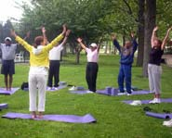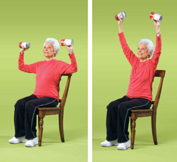

Would you like to see some activities for older people in Alexandra Park this summer?
What would you be interested in?
Please tick the suggested activities and taster sessions below - or add your own!

Tai Chi

Bird watching

Walking

Fitness sessions

Memory Collecting

Other (please specify)

Your age: …………………………………………………

Your postcode: ……………………………………………

Please return the survey to the lodge in the park or to
JNR8 Community Centre,
82 Cromwell Avenue,
Whalley Range
M16 0BG

Contact Chris at agefriendlywhalleyrange@gmail.com
or call 881 3744 to join our age-friendly mailing list.

Visit our website for lots of community and age-friendly news www.whalleyrange.org

