New proposals brought forward for, LGBT+ majority Extra Care housing scheme

Second consultation to take place for the development of the former Spire Hospital site in Russell Road Whalley Range Manchester

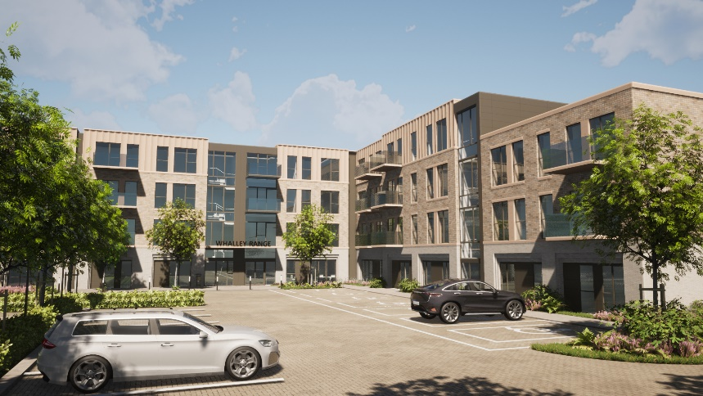

Anchor, England’s largest not-for-profit provider of specialist housing and care for people in later life, is seeking views once more from local residents at a consultation event next week ahead of a planning application submission for around 100 new affordable homes. The development is planned for the site of the former Spire Hospital in Russell Road, Whalley Range, Manchester, which was demolished in 2019, and the brownfield site has since remained vacant.

In partnership with Manchester City Council and a Community Steering Group led by LGBT Foundation, Anchor aims to develop an Extra Care scheme on Russell Road, Whalley Range, designed to be the UK's first purpose built LGBT+ majority housing development exclusively for older people.

The first consultation event, which took place in January in person and online, presented the initial thinking for the proposed new development. At this second event, visitors will be able to view more detailed designs ahead of the planning application being submitted.

The proposals will deliver high-quality, inclusive new homes for older people and propose around 100 one- and two-bedroom apartments, in a brick building of three and four storeys. All homes will be designed for affordable rent and shared ownership, plus shared facilities including a restaurant/bistro, lounges, treatment rooms and landscaped outdoor amenity space plus parking. Residents will be required to be aged 55 years or over, and the scheme will be inclusive of members and non-members of the LGBT+ community from Manchester.

The development seeks to minimise its carbon impact through a number of smart design measures to improve thermal efficiency throughout. Designs propose the use of renewable energy sources such as solar power and air source heat pumps, and installation of resource efficient equipment throughout the building, such as heat recovery ventilation systems and intelligently controlled LED lighting. The current target is to achieve an accreditation of ‘BREEAM Excellent’ for the new extra care housing scheme and will install electric vehicle charging points to a proportion of the residents’ parking bays. This will place the new development within the top 10 per cent of new builds in terms of sustainability both connected to the building and the setting.

Charles Taylor, Anchor’s Director of New Business, said:
“The first consultation was well attended and we got some great feedback. We’re looking forward to presenting our updated proposals for further views before we submit a planning application to Manchester City Council.

“At Anchor we have developed a strong reputation for delivering high-quality homes where people love living in later life. We share the collective ambition with Manchester City Council to create an exemplary, inclusive development on this well-located site in the heart of the Whalley Range community.”

Cllr Gavin White, Manchester City Council's executive member for housing and employment, said: "It's brilliant to see this project starting to move at pace. This is the second consultation for the LGBT majority extra care scheme and the feedback received has been really useful in developing the proposals that will go to planning in the coming weeks.

"We want this to be an exemplar for inclusive older person's housing and to do that we need input from the communities that will eventually live there. This is a great opportunity to see how the development is progressing and we'd love to get as many people's views as possible as we move into the next stage of the project."

Paul Martin OBE, CEO LGBT Foundation, said: “LGBT Foundation is proud to have been involved in the development of the LGBT+ majority Extra Care scheme in Whalley Range since it was proposed some years ago. We were delighted to hear the overwhelming support for the scheme during the first consultation.

“The views of the local community are key to making this development a success and we encourage people to use their voice to help shape the future of this landmark project, to ensure it offers a safe and welcoming home for older LGBT+ people.”

The consultation will be held at Whalley Range Methodist Church between 2pm and 8pm, Wednesday 16th February. In addition to the in-person event, all the information presented will be displayed online at www.anchor.consultationonline.co.uk from 16 February 2022. Local residents will be able to provide their views via a feedback form at the event or online until 23 February 2022.

ENDS

Notes to Editors
For further information, contact:
Sam Freedman / 020 3219 7956
Esme Roberts / 020 3697 7633

About Anchor

Anchor began more than 50 years ago and today is England’s largest not-for-profit provider of housing and care for people in later life. It provides retirement housing to rent and to buy, retirement villages and residential care homes, including specialist dementia care. In total, Anchor serves more than 65,000 residents in 55,000 homes across almost 1,700 locations. Its residential care services employ the majority of the 9,000-strong workforce, providing services to residents at 114 care homes. Anchor operates in more than 85% of local councils in England. For more information visit www.anchor.org.uk.

About LGBT Foundation

LGBT Foundation is a national charity delivering advice, support and information services to lesbian, gay, bisexual and trans communities. With a history dating back to 1975, they campaign for a fair and equal society where all LGBT people can achieve their full potential. Through their services, they reduce isolation amongst LGBT communities, help people feel more confident and in control of their lives and enable people to flourish. Together with LGBT communities and their supporters, LGBT Foundation are working to secure a safe, healthy and equal future for all LGBT people.

lgbt.foundation | @LGBTfdn

What is an Extra Care scheme?
Extra Care schemes typically attract customers who are already living in the area that require more specialist accommodation to meet their personal needs; but do not require levels of wellness provision which justifies moving into a care home. This model is especially attractive to those who live on their own and may need some physical and/or emotional support; and it is also for those who want to live within a community of like-minded people. The proposed development will therefore include specialist design features attributable to Extra Care schemes to enable residents to live independently in their own homes but with care and wellness services provided as and when required.

