Ideas for cheap days out

Clarence Mill & Adelphi Mill (Bollington) | Places to visit | Canal & River Trust (canalrivertrust.org.uk)

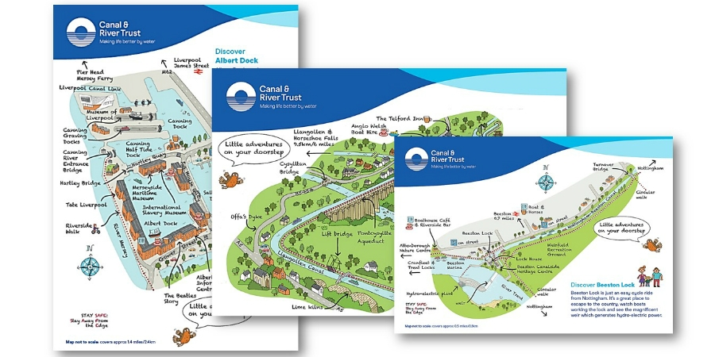

Download free local map
No. 10 bus from Macclesfield station

A great place to discover the past when Clarence and Adelphi Mills, sat along side the Macclesfield Canal, clattered non-stop with the machinery spinning cotton. Why not start your visit at Bollington Discovery Centre and pick up a free guide to the area.

Portland Basin | Portland Basin | Canal & River Trust (canalrivertrust.org.uk)
Portland Basin
Portland Basin is at the junction of the Peak Forest, Ashton and Huddersfield Narrow canals. It's a great place where canals, boats and people meet, there is a museum in the old Ashton Canal warehouse offering lots of family friendly activities.
No 216 bus from Piccadilly Gardens

Nature Reserves under 10 miles from Whalley Range Community Forum
Nature Reserves | The Wildlife Trust for Lancashire, Manchester and North Merseyside (lancswt.org.uk)
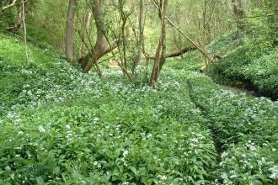

Wildlife events – a bit further afield
Events | The Wildlife Trust for Lancashire, Manchester and North Merseyside (lancswt.org.uk)

Trip /Advisor best budget places to visit in Manchester
THE 10 BEST Cheap Things to Do in Manchester (Updated 2023) (tripadvisor.co.uk)

33 free things to do in Manchester – Manchester’s finest
33 FREE Things To Do in Manchester (manchestersfinest.com)

